Ideation Phase

Define the Problem Statements

|  |  |
| --- | --- |
| Date | 11 November 2022 |
| Team ID | PNT2022TMID52122 |
| Project Name | VirtualEye - Life Guard for Swimming Pools to Detect Active Drowning |
| Maximum Marks | 2 Marks |

Problem statements:

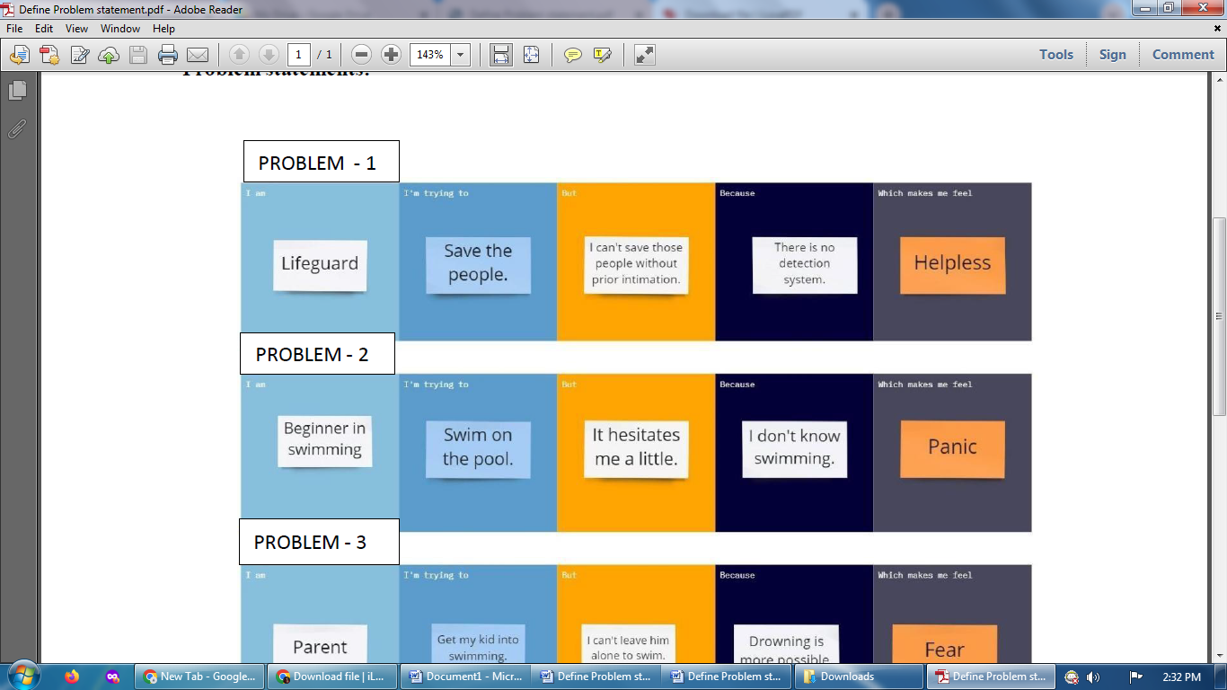

|  |  |  |  |  |  |
| --- | --- | --- | --- | --- | --- |
| Problem statement (PS) | I am  (Customer) | I’m trying to | But | Because | Which makes me feel |
| PS-1 | Lifeguard | Save the people. | I can’t save those people without prior intimation. | There is no detection system. | Helpless |
| PS-2 | Beginner in swimming | Swim on the pool. | It hesitates me a little. | I don’t know swimming. | Panic |